SECTION A: 40 MARKS
Questions 1 to 40 carry one mark each

- Name the type of lakes formed by Marine deposition.
………………………………………………………………….…………………………
- Why are funeral rites referred to as social activities?
……………………………………………………………………………….………….…
- Identify one reason why air transport is used by very few people in Uganda.
………………..……………………………………………………………………………
- Why is road and railway transport not well developed in equatorial climate region.
…………………………………………………….………………………………………
- Why should school children welcome people who visit their homes?
……………………………………………………………………..………………………
- How did Alexandra Mackay promote self-employment in Uganda?
………………………………………………………….………..………………………
- How was the struggle for independence in Uganda different from that of Tanzania?
………………………………………………………………………………………….…
- Why is Entebbe town politically important in Uganda?
……………………………………………………………………………………..………
……………………………………………………………………………………………
- How do masons contribute to the provision of basic needs to people?
……………………………………………………………………………………………
- State one reason why political parties were formed in East Africa during 1950s.
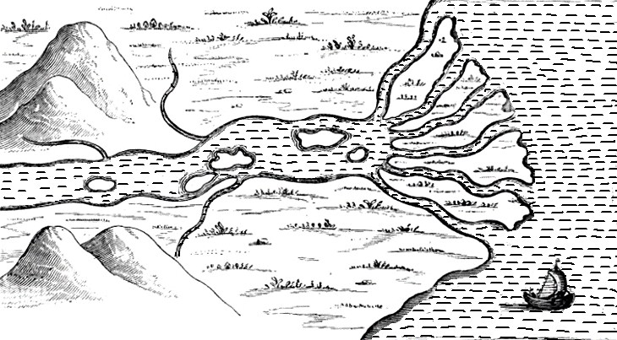
………………………………………………………………………………………..……

.

11.

Sea
The diagram below shows a river flowing to the sea. Use it to answer

11. What name is given to the feature formed when a river separates into channels while entering the sea as shown in the diagram above?
…………………………………………………………………………………………….

- Name any one river in Africa that enters the sea in the same way as shown in the diagram above.
…………………………………………………………………………….………………
- Give any one economic importance of wind.
…………………………………………………………………………………..………
- Give any one reason why places that have industries are highly populated.
……………………………………………………………………………….……………
- Why does Africa receive abundant sunshine throughout the year?
…………………………………………………………………………….………………
- How did the missionaries help to reduce illiteracy in Africa?
………………………………………………………………………………………
- How do television stations promote trade in an area?
……………………………………………………………………………………………
- Which problem does a map reader solve when he/she uses the map element below?
A SKETCH MAP OF UGANDA SHOWING NATIONAL PARKS

……………………………………………………………………………………………
- State any one importance of Victoria Falls to the industrial development of Zambia.
……………………………………………………………………………………………
- Why is a school badge important on a school uniform?
……………………………………………………………………………………………

- Mention the group of people in Uganda on which ‘Pay as You Earn’ (PAYE) is charged.
……………………………………………………………………………………………
- Give any one factor that brings about difference in wildlife distribution in East Africa.
……………………………………………………………………………………………
- Apart from beautifying the compound, give any one other reason why a home should have trees.
……………………………………………………………………………………………
- Mention any one way in which a school can solve the problem of misunderstandings with its neighbourhood.
……………………………………………………………………………………………
- Give any one reason why a government should have a law making body.
…………………………………………………………………………………………
- State any one way in which the use of solar energy reduces the rate of deforestation.
……………………………………………………………………………………………
- How did the coming of white settlers affect the kikuyu in Kenya highland?
…………………………………………………………………………………………

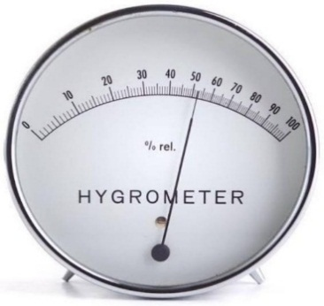
The diagram below shows one of the instruments kept in a Stevenson screen. Use it to answer questions 28 and 29.

- State the use of the above weather instrument at a weather station.
……………………………………………………………………………………………
- Why is the above weather instrument kept in a Stevenson screen?
…………………………………………………………………………………………
- Why is Lesotho referred to as an enclave country?
………………………………………………………………………………..…………
…………………………………………………………………………………………
- Which group of foreigners benefited from finding the sea route to India?
……………………………………………………………………………………………
- State any one factor that has promoted agricultural development in East Africa.
………………………………………………………………………..…………………

- Which drainage feature is shared by Tanzania and Democratic Republic of Congo (DRC)?
……………………………………………………………………………………………
- State any one role played by RDC.
……………………………………………………………………………………………
- Mention any one activity the Environment Management Club in your school can carry out to overcome harsh weather conditions.
……………………………………………………………………………………………
For each of the questions 36 to 40, answer Either the Christian OR Islamic questions but not both. No marks will be awarded to a candidate who attempts both alternatives in a particular number.

36. EITHER:
Which book in the Bible gives details about the creation of the Universe?
………………………………………………………………………………………….
OR:
Which holy book did Allah reveal to give a summary of previously revealed books?
…………………………………………………………………………………………

37. EITHER:
Mention any one sign of the Holy Spirit on the Pentecost day.
…………………………………………………………………………………………

OR:
Mention any one pillar of Islam that promotes unity among Muslims.
………………………………………………………………………………………..

38. EITHER:
State any one way Christians reconcile with fellow pupils in class.
…………………………………………………………………………………………

OR:
State any one way Muslims reconcile with fellow pupils in class.
…………………………………………………………………………………………

39. EITHER:
Give any one reason why Jesus performed miracles in His teaching.
…………………………………………………………………………………………
OR:
Give any one reason why Prophet Muhammad (P.B.U.H) performed miracles in his teaching.
…………………………………………………………………………………………

40. EITHER:
State any one way the Lord’s Prayer is important to Christians.
………………………………………………………………………………………….
OR:
State any one way Juma prayer is important to Muslims.
…………………………………………………………………………………………

SECTION B: 60 MARKS
Questions 41 to 55 carry four marks each.
41. Study the sketch map of Tanzania below and use it to answer the questions that follow.
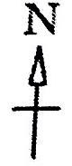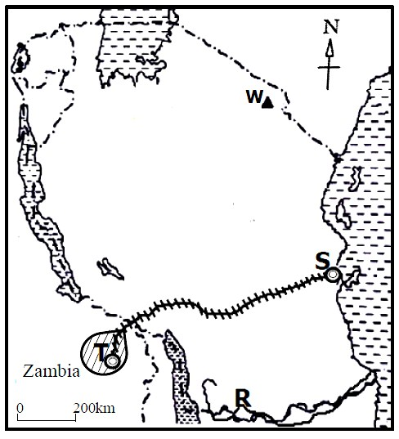

W

T

Zambia

W

- Name the sea port marked S.
……………………………………………………………..…………………………….……..
- Name the major mineral exported from area T using the railway line on the map.
c) State the political importance of River marked R to Tanzania.
…………………………………………………..……………………………………………
d) How are the Bagisu of Uganda similar to the people that live on the slopes of mountain W in terms of economic activities?
……………………………...…………………………………………………………………
…………………………………………………………………………………………………
- a) Which common market has its motto as “One People One Destiny”?
…………………………………………………..…………….................................
  - State any one way in which the above common market promotes trade.
……………………………………………………….…………………………..…
c) Apart from promoting trade, give any two other ways in which member states benefit from the common market given in a) above.
    - …………………………….………………………….…………………………
    - ………………………………………………………………………………….
- a) Identify any two economic values of land as a natural resource.
    - …………………………………………………………………..………………
    - …………………………………………………………………………………..
  - Give two ways people have misused land as a resource.
    - ……………………………………………………………………………………
    - …………………………….………………………………………..……………
- a) Name the system of administration that was used by the British colonialists in Uganda.
……….……………………………………………………………………………….…………
  - Give any two ways in which the British colonialists benefited from the above system of administration.
    - ……………………….…………………………………………………………..…………
    - …………………………………………………..…………………………………………
  - Mention any one other country in East Africa where the system of administration named in a) above was used.
………………………………………………………………………………….………………
- The diagram below shows the types of mountains in Africa. Use it to answer the questions that follow.


MOUNTAINS

BLOCK
MOUNTAINS

X

VOLCANIC
MOUNTAINS

Y

CAPE
RANGES

Z

  - Name the type of mountain marked X.
………………………………………………...…………………………………
  - Mention any one mountain that can be put at;
    - Y ………………………………………………………………………
    - Z ………………………………………………………………………
c) How was the formation of the mountain put at Y similar to that of the rift valley?
……………………………………………………………………………………
- a) David grows tea on a large scale. Name the type of farming that David practices.
…………………………………………………………………………………………
  - State any two advantages of the system of farming named in a) above.
    - …………………………………..………...….…………………………
    - ………………………………………….………………………………
  - Give any one reason why most farmers in Uganda do not practice the system of farming named in a) above.
….…….………………………..……………………………………………..
- a) Which arm of a democratic government is headed by the;
    - President?…………………………………….……………………
    - ii) Chief justice? …………………………………………………
  - Give any two duties of the arm of the democratic government headed by the president.
    - ………………………………………………………………………
    - ………………………………………………………………………
- a) Give any two causes of traffic jam on major roads in Uganda..
    - ……………………………………………………………………
    - ………………………………………………………………………
  - State any two measures that the government of Uganda can apply to control traffic jam on the major roads.
    - ……..………………………………………………………………....
    - ……..…………………………………………………………………
- a) Name the major mineral mined at;
i) Osukuru hills ………………………………………………………………………….........
ii) Mwadui ……………………………………………………………………………....
  - Give any one way in which minerals have contributed to the economic development of East African countries.
……………………………………..……………………………………….
  - State any one reason why some minerals in East Africa are not fully exploited.
……………………………………..…………………………………………

50. Study the sketch map of Africa below and use it to answer the questions
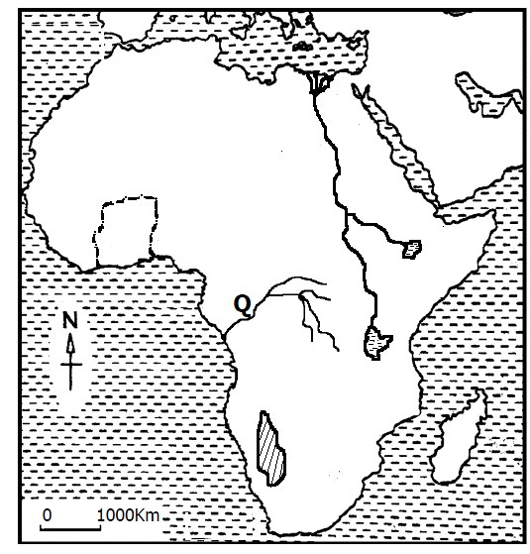

that
follow.

a) Name lake marked
W

On the map.

KEY

M
P

W

U

……………………………………………….……………….…………..…
- What evidence shows that river marked Q has many tributaries?
………………………………………………………………………………
- Which line of longitude passes through country marked P?
…………………………………………………………………………………
- Mention any one factor that influences the climate experienced at desert marked U.
………………………………………………………………………………..

For each of the questions 51 to 55, answer EITHER the Christian OR Islamic questions but not both. No mark will be awarded to a candidate who attempts both alternatives in a particular number.

51. EITHER:
- Mention any one punishment God promised for Christians who go against His orders.
…………………..…………………………………………………………………
- State any two reasons why God prescribed severe punishments for Christians who go against His orders.
    - ……………………………………………………………
    - …………………………………………………………………
- State one way Christians can save themselves from the punishments God promised them for sinning.
………………………………………………………………………………………

OR:
- Mention any one punishment Allah promised for Muslims who go against His orders.
……………………………………….……………………………………………
- State any two reasons why Allah prescribed severe punishments for Muslims who go against His orders.
    - …………………………………………………………………
    - ……………………………….…………………………………
- State one way Muslims can save themselves from the punishments Allah promised them for sinning.
……………………………………………………………………………………

52. EITHER:
- What title is given to groups of Christians who make long journeys from their areas to places where Uganda martyrs were burnt from?
………………………………………………………………………..…………………………………………………………………………………………………..
- Name any one place in Uganda where Uganda martyrs were burnt.
……………………………………………………………………..…………
- Give any two ways in which the people named in a) above benefit from visiting places where Uganda Martyrs were burnt from.
  - …………………………………………………………………………..
  - …………………………………………………………………………..

OR:
- What title do the following Muslims get after making Hijja?
- Male Muslims ………………………………………………………………………………
ii) Female Muslims …………………………………………………………………………………….
- Mention any one place Muslims visit when performing Hijja rites.
………………………………………………………………………………………………………………………………..…
- Give any one way Muslims benefit from performing Hijja.
…………………………….………………………………………………………

53. EITHER:
- State one way the following people expressed their faith in God according to the Bible.
  - Abraham …………………………………………………………….………………
  - Moses …………………………………………………….………………………
- Give any two ways Christians express strong faith in God today.
  - ………………………………………………………………………………
  - ………………………………………………………………………………

OR:
- State one way the following prophets expressed their Iman in Allah according to the Qur’an.
  - Prophet Ibrahim ………………………………………………..……………………………
  - Prophet Musa ……………….…………………………………….………………………
- Give any two ways Muslims express strong Iman in Allah today.
  - ……………………………………………………………………………
  - ………………………………………………………………………………………..…………….……………………………………………………….

54. EITHER:
- Which group of foreigners introduced Christianity in Uganda?
……………………..……………………………………………………………………..……………………..……………………………………………....………
- Give any two ways the people named in a) above promoted Christianity in Uganda.
- ………………………………………………………………………………..
- ……………………………………………………………………………….
- Mention any one factor that has caused disunity and division among Christians in Uganda today.
…………………………………………….………………………………………

OR:
- Which group of foreigners introduced Islam in Uganda?
……………………..………………………………………………………………………………………………………………………………………………..……
- Give any two ways the people named in a) above promoted Islam in Uganda.
- ……………………………………………………………………….…………
- ……………………………………….…………………………………………
- Mention any one factor that has caused disunity and division among Muslims in Uganda today.
…………………………………………………………………………………………..

55. EITHER:
- Give the meaning of the term marriage in Christianity.
………………………………………………………………….……………………
………………………………………………………………………………..……..
- Give any one condition necessary for Christian marriage to take place.
………………………………………………………………………………….…
“…….for this reason a man will leave his father and mother and unite with his wife.” (Mathew 19:5)
c) According to Christianity, give any two things a wife can do to please a man she has united with in marriage.
i) …………………………………………………………………………………
ii) ………………………………………………………………..………………

OR:
- Give the meaning of the term Nikkah in Islam.
……………………………………………………………………………………..
……………………………………………………………………………………..
- Give any one condition necessary for Nikkah to take place.
……………………………………………………………………………………
“Any woman who dies while her husband is pleased with her, she will enter paradise.” (Narrated by Tirmidhi)
- According to Islam, give any two things a woman can do to please her husband during marriage.
  - …………………………………………………………………………….
  - ……………………………………………………………………………

END

